SALES FUNNEL MAGIC MADE EASY

A Beginner’s Guide to Designing a High-Converting, Automated Online Sales Funnel

Action Guide

Table of Contents

How to Use Your Action Guide 4
Module 1 - What Is a Sales Funnel and Why Is It Important for Your Success? 6
What Happens In Your Sales Funnel 7
Sales Funnel Planning Checklist 8
Funnel Content to Create 9
Module 2 - The Key Components of an Effective Sales Funnel 11
Module 3 - Ideas for Your Sales Funnel 12
Module 4 - What Are the Best Types of Opt-in Offers? 16
Module 5 – The Entrance to Your Sales Funnel: The Opt-In Page 19
Module 6 - What Are One-Time Offers and How Do They Work? 22
Module 7 - Email Follow-ups: What to Send Your List 24
Module 8 - What Products Should You Promote in Your Follow-ups? 25
Module 9 - Is Your Sales Funnel Working for You? 27
Module 10 - The Best Tools for Creating a Sales Funnel 30
Conclusion 32

How to Use Your Action Guide

You’ll get the best results from any course you participate in by completing the Action Steps at the end of each module. They will help you apply what you learn directly to your business and your life, maximizing the investment you’re making.
Use the following Action Guide to record your answers, insights, and other notes for the Action Steps, which are outlined in your Course Book. You’ll want to refer to each module’s content as you complete the related steps.
While we have left space in the guide for each action step, you may feel more comfortable using a separate notebook or digital application for your work. Use whatever method you feel most comfortable with and don’t feel constrained to using the space in the Action Guide alone.

In addition, your course may have other Action Sheets, such as spreadsheets or planning templates, which are separate from the guide. Look out for those with your other course materials.
Finally, you don’t have to complete all the steps at once. Instead, try setting a specific time on your calendar to work on them. And don’t feel that you have to get it right the first time. Learning is a process that happens as you apply your new skills and knowledge. You’ll want to return periodically to your Action Guide and both remind yourself of the work you’ve achieved and edit your answers as you see their impact.
Have fun with it and enjoy the progress and successes that will happen as a result of your work!

Introduction

Expectations
Before we start the course, take a minute to think about what you want to get out of it.
Write down three skills you expect to gain.

1
2
3

Module 1 - What Is a Sales Funnel and Why Is It Important for Your Success?
- Do you already have a sales funnel? If so, compare the amount of sales you’ve made from your sales funnel vs. products you’ve sold through other methods.
% of Sales From Funnels | % of Sales From Other Marketing

- If you don’t have a sales funnel already, start thinking about what part of your business would benefit most from creating one.

- Review the graphic at the start of this module – What Happens in Your Sales Funnel – so that you’re familiar with it for the rest of the course.
- Use the Sales Funnel Planning Checklist throughout this course and at the end to make sure you’ve completed all the necessary steps.
(Provided below and in a separate document)

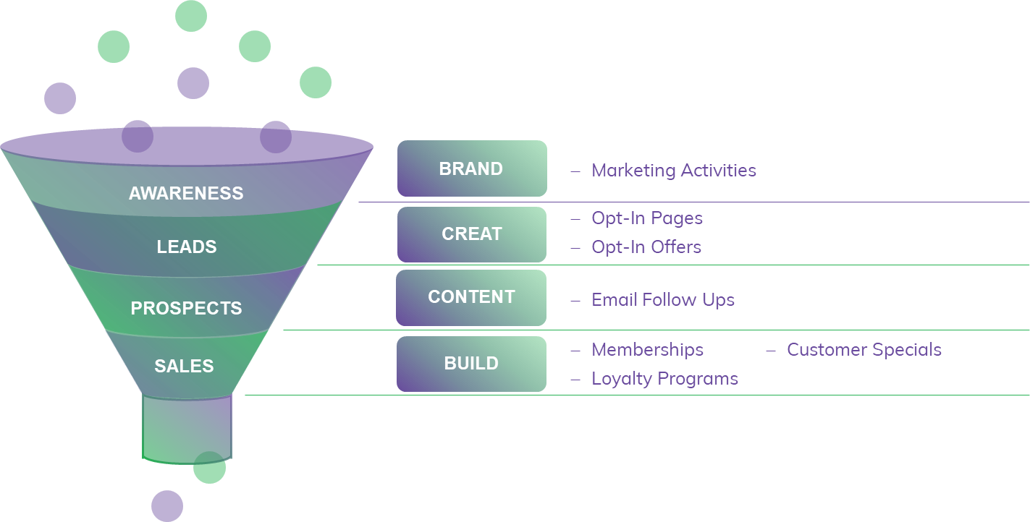
What Happens In Your Sales Funnel

Loyal Customers

Sales Funnel Planning Checklist
Purpose of
Funnel
Target
Audience
Opt-In
Offer
One-Time
Offer
Additional Products to Promote
High-Ticket
Upsells

Funnel Content to Create
Page | Notes | Check
Opt-In Page with Free Offer
- Video, text or audio?
- Who will Create it?
Thank You Page
- Additional offers or information on page
Download Page
- Additional offers or information on page
Additional One-Time-Offer Page
- Limited time
- Limited number
- Temporary price reduction
- Other
Sales Page
- Text, video or audio
- Who will create it?
- Email follow-up series

Module 2 - The Key Components of an Effective Sales Funnel
Think about sales funnels you’ve been filtered through yourself:
- What were the components? List them or draw them below:

- What types of funnels did you find attractive or compelling?

- What components turned you off?

Module 3 - Ideas for Your Sales Funnel
Start researching and planning your own sales funnel. This is just a draft at this point, so don’t worry if you need to go back and edit it.
- What is the purpose of your funnel?

- Who will be your target audience?

- What do your competitors’ funnels look like? Where can you improve?
Here’s one example of a solid sales funnel that you can use as a guide for planning your own.

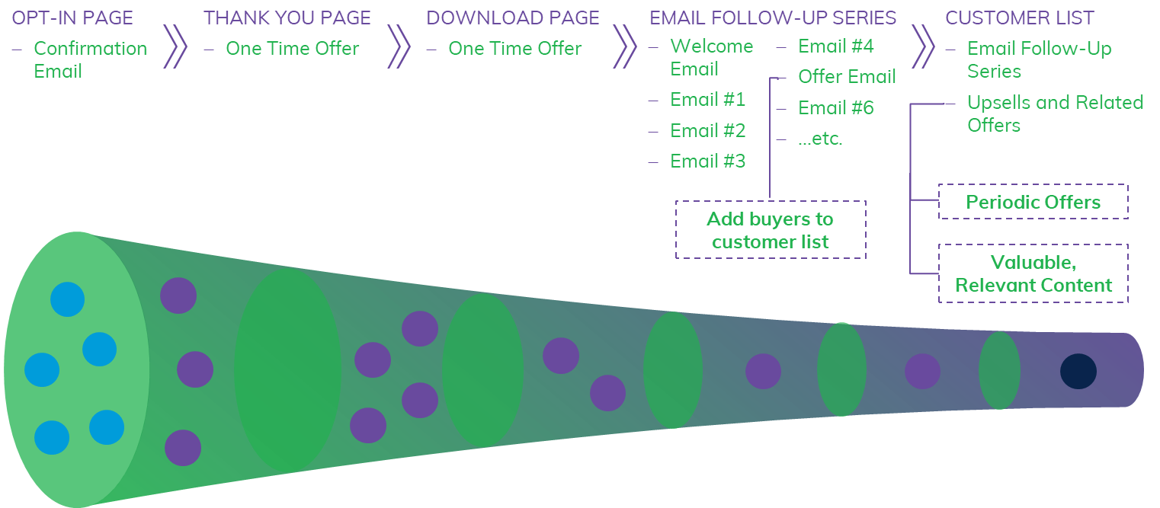

Start drawing a visual of your own sales funnel here:

Module 4 - What Are the Best Types of Opt-in Offers?
Brainstorm different opt-in offers for the start of your funnel and identify the one you will use. Use this Opt-In and Product Offers Brainstorming Worksheet below to make notes:
- Who is your ideal customer?
(Write a brief description of your ideal target customer in terms of demographics, primary needs, problems, desires, issues, likes, dislikes, etc.)

- Urgent needs or problems
(Brainstorm specific needs or problems that your target customers are desperate to address. Get ideas by looking at forums, blog comments, social media, surveys, customer feedback, and other places where your market is talking.)
- Solutions you can offer
(Brainstorm specific solutions you can offer for parts of a larger problem. For example, if one problem is “increasing the size of my email list”, one specific solution could be “how to use paid solo ads to grow your list”.)

Pick 3 ideas from your list of solutions and brainstorm possible opt-in offers and the best format to present each one in. Focus only on those related to the sales funnel you are currently planning.
Opt-In Offer 1:
Best format:
(e.g., short report, video, audio, email ecourse, software tool, worksheet, resource list, etc.)

Opt-In Offer 2:
Best format:

Opt-In Offer 3:
Best format:

Who will create your offer?

Module 5 – The Entrance to Your Sales Funnel: The Opt-In Page
- Look around at opt-in pages that you like and note which aspects you want to use on your own.

- How will you create your opt-in page? We recommend using a special landing page plugin for WordPress like OptimizePress or a platform that specializes in landing pages, such as LeadPages, Unbounce, and ClickFunnels. All these tools will give you templates already proven to convert.

- Write out some draft copy for your page, especially the features and benefits of your opt-in offer. Templates from landing page tools can help guide your copy. For example, be sure to include:
Title:
Subtitle:

- Benefit 1:
- Benefit 2:
- Benefit 3:

Call to Action (eg GET INSTANT ACCESS)

Testimonial 1

Testimonial 2

Module 6 - What Are One-Time Offers and How Do They Work?
Brainstorm different one-time offers and identify one you can use in your funnel. Use the Opt-In and Product Offers Brainstorming Worksheet below to take notes.
Types of Specials:(e.g., bundle of products, introductory price, one month free, bonus for people that buy now, bonus for people that buy through my affiliate link)

Your own products:

Affiliate partner products:
Write down the offers you will add to your funnel below and where it will appear. NOTE: You do not have to have any additional offers right now, but it helps to start thinking about what you can add in the future.
Offer 1:
Where it will appear:
Offer 2:
Where it will appear:
Offer 3:
Where it will appear:

Module 7 - Email Follow-ups: What to Send Your List
Use the Email Planning Spreadsheet or another tool to plan out the topics for at least 7 emails in your follow-up series.
Topics & Offers:
- Welcome plus link to download page
(For example, make Opt-In Offer rebrandable for affiliate, write additional emails and promotional material for affiliates, contact potential affiliates and joint-venture partners to promote funnel, create webinars for promoting funnel, etc.)
Additional tasks

Module 8 - What Products Should You Promote in Your Follow-ups?
Brainstorm different offers you can make in follow-up emails or as future higher-ticket upsells.
Related Products:(What products can you offer that are related to your opt-in offer and main product?)
Your own products:
Current affiliate partners:
Your colleagues in your industry:
Tools and Services You Already Use:

Clickbank and other affiliate networks:

High-Ticket Upsells: (What are some potential high-ticket products or services you can offer later in the sales funnel or in the future? Examples include membership sites, private coaching ‘vacations’, combination self-study and live training sessions, larger product bundles, etc.)

Now go back to your Email Series Planning spreadsheet and revise your follow-up plan to include your additional offers.

Module 9 - Is Your Sales Funnel Working for You?

- Identify the elements of your sales funnel that you will be measuring:
Elements | Check
Clicks from Traffic Sources
Opt-In Page Conversions (list signups)
Email Opens
Email Link Clicks
Sales Conversions on Different Offers
Other:
Other:

- What will you measure at each stage of your sales funnel? You can refer to your map of your funnel and note the measures next to each component or use the table below.
Funnel Stage | Metric(s) to Measure
Traffic Sources:
Opt-In Page
One-Time Offer(s):
Emails
Offer:
Offer:
Offer
High Ticket Upsell:

- What tools will you use for those measures, i.e. where will you find the data? (Preferably within the sales funnel tools you are using.)

- If you already have a funnel in place, look at those measures and identify places you can improve.

Module 10 - The Best Tools for Creating a Sales Funnel
- What tools are you currently using in your sales funnel?
Sales Page Tools:

Follow-Up Tools (autoresponder):

Product Sales Tools (eg, shopping cart):

- If you’re just starting out, what tools do you need to acquire or want to change?
Tools | Check
Sales Page Tools
Follow-Up Tools (Autoresponder)
Product Sales Tools (eg, Shopping Cart)

- Start doing your research and getting recommendations. Select the ones that look easiest to use for a beginner.
Sales Page Tools to Test:

Follow-Up Tools to Test:

Product Sales Tools to Test:

Conclusion
- Do a final review of your Sales Funnel Planning Checklist to make sure you have everything in place for a successful funnel.
- Use the planning table below and start taking action!
 | Action to Take | Action Deadline
1
2
3
4
5
6
7
8
9
10

